CIA 1

QUESTION 1:

package com.cia1;

import org.openqa.selenium.By;

import org.openqa.selenium.WebDriver;

import org.openqa.selenium.WebElement;

import org.openqa.selenium.chrome.ChromeDriver;

import org.openqa.selenium.chrome.ChromeOptions;

import io.github.bonigarcia.wdm.WebDriverManager;

public class Question1 {

public static void main(String[] args) throws InterruptedException {

WebDriverManager.chromedriver().setup();

WebDriver driver;

ChromeOptions co=new ChromeOptions();

co.addArguments("--remote-allow-origins=*");

driver=new ChromeDriver(co);

driver.navigate().to("https://www.amazon.in/Apple-iPhone-14-512GB-Purple/dp/B0BDJYHP2H/ref=sr_1_1_sspa?keywords=iphone+14&qid=1681288324&sprefix=iphon%2Caps%2C587&sr=8-1-spons&sp_csd=d2lkZ2V0TmFtZT1zcF9hdGY&psc=1");

driver.manage().window().maximize();

WebElement addtocart=driver.findElement(By.id("add-to-cart-button"));

addtocart.click();

Thread.sleep(5000);

WebElement cartbutton=driver.findElement(By.xpath("//*[@id=\"attach-sidesheet-view-cart-button\"]/span/input"));

cartbutton.click();

Thread.sleep(5000);

WebElement proceedtobuy=driver.findElement(By.name("proceedToRetailCheckout"));

proceedtobuy.click();

System.out.print("Sucessfully placed order");

System.out.print("Sucessfully placed order");

}

}

Output:

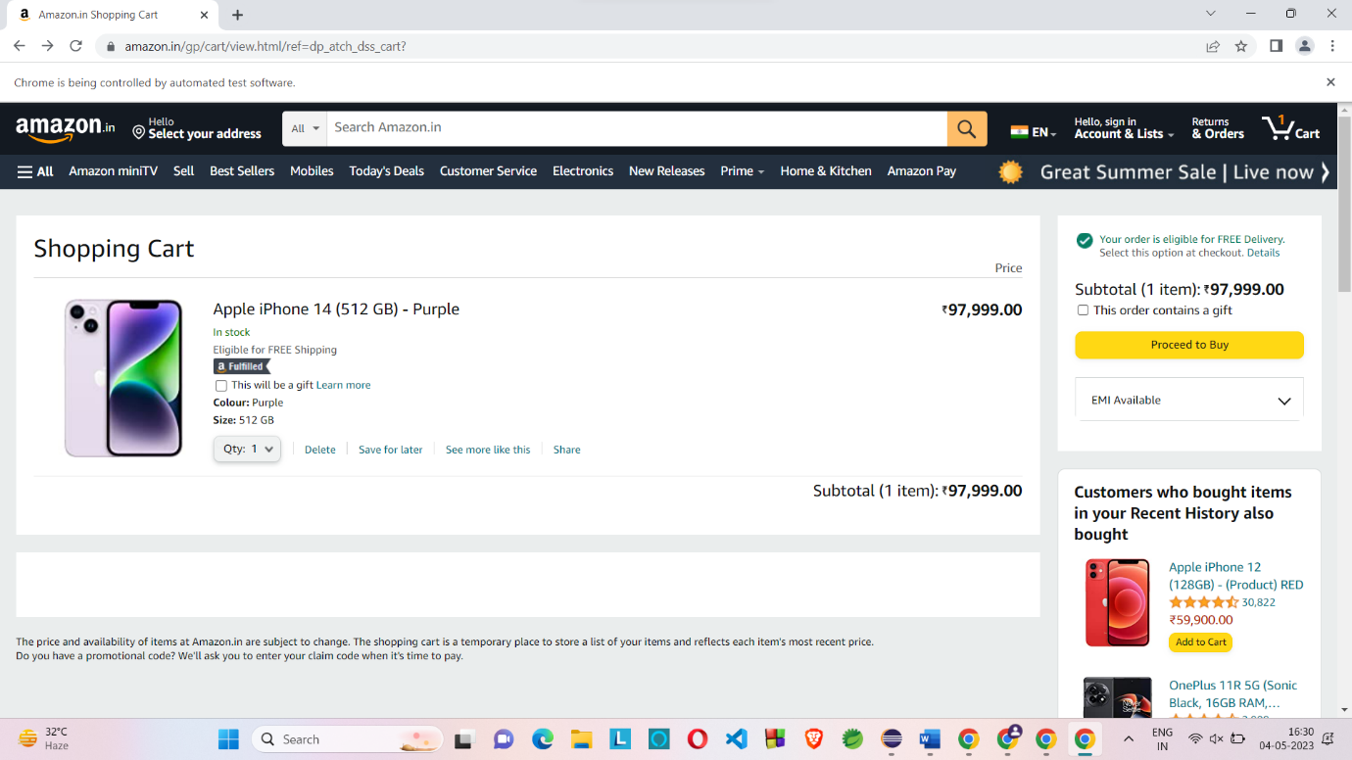

QUESTION 2

CODING:

package com.cia1;

//import java.util.ArrayList;

import java.util.List;

import org.openqa.selenium.By;

import org.openqa.selenium.WebDriver;

import org.openqa.selenium.WebElement;

import org.openqa.selenium.chrome.ChromeDriver;

import org.openqa.selenium.chrome.ChromeOptions;

import io.github.bonigarcia.wdm.WebDriverManager;

public class Question2 {

public static void main(String[] args) {

WebDriverManager.chromedriver().setup();

WebDriver driver;

ChromeOptions co=new ChromeOptions();

co.addArguments("--remote-allow-origins=*");

driver=new ChromeDriver(co);

driver.navigate().to("https://www.amazon.in/");

driver.manage().window().maximize();

WebElement searchbox=driver.findElement(By.id("twotabsearchtextbox"));

searchbox.sendKeys("iphone14");

WebElement yesbutton=driver.findElement(By.id("nav-search-submit-button"));

yesbutton.click();

WebElement checkbox =driver.findElement(By.xpath("//*[@id=\"p_90/6741118031\"]/span/a/div/label/i"));

checkbox.click();

List<WebElement> products = driver.findElements(By.xpath("//*[@id=\"search\"]/div[1]/div[1]/div/span[1]/div[1]/div[2]/div/div/div/div/div/div[2]/div/div/div[1]/h2/a/span"));

for (int i = 0; i < products.size(); i++) {

String productName = products.get(i).getText();

System.out.print(productName);

}

}

}

OUTPUT:  
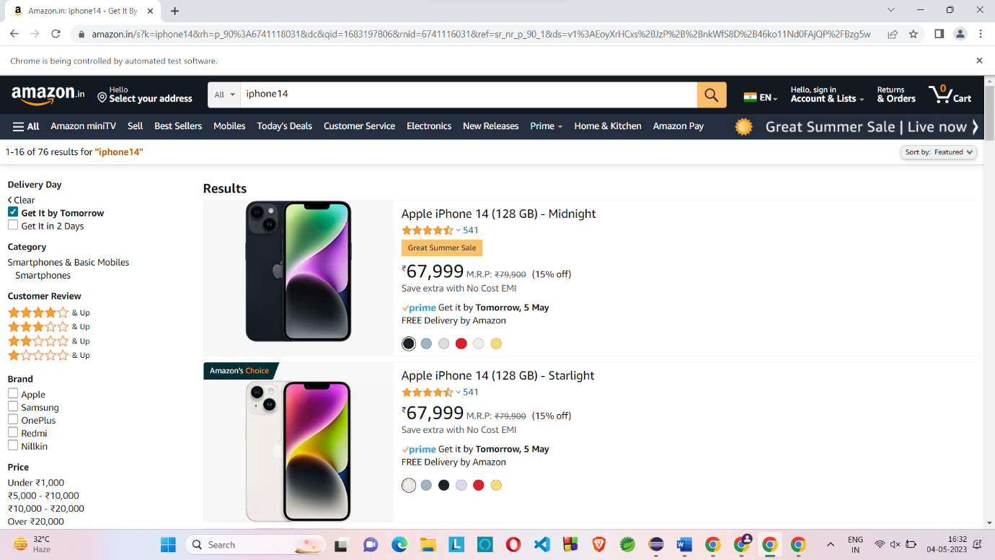

QUESTION 3:

CODING:

package com.cia1;

import org.openqa.selenium.By;

import org.openqa.selenium.WebDriver;

import org.openqa.selenium.WebElement;

import org.openqa.selenium.chrome.ChromeDriver;

import org.openqa.selenium.chrome.ChromeOptions;

import org.openqa.selenium.interactions.Actions;

import io.github.bonigarcia.wdm.WebDriverManager;

public class Question3 {

public static void main(String[] args) throws InterruptedException {

WebDriverManager.chromedriver().setup();

WebDriver driver;

ChromeOptions co=new ChromeOptions();

co.addArguments("--remote-allow-origins=*");

driver=new ChromeDriver(co);

driver.navigate().to("https://www.amazon.in/");

Actions actions = new Actions(driver);

WebElement element = driver.findElement(By.xpath("//*[@id=\"nav-link-accountList\"]/span"));

actions.moveToElement(element).perform();

Thread.sleep(3000);

WebElement link = driver.findElement(By.xpath("//*[@id=\"nav-al-your-account\"]/a[1]/span"));

link.click();

Thread.sleep(3000);

WebElement yourorder=driver.findElement(By.xpath("//*[@id=\"a-page\"]/div[2]/div/div[2]/div[1]/a/div/div"));

yourorder.click();

Thread.sleep(3000);

WebElement searchbox=driver.findElement(By.xpath("//*[@id=\"ap_email\"]"));

searchbox.sendKeys("8056605417");

WebElement yesbutton=driver.findElement(By.xpath("//*[@id=\"continue\"]"));

yesbutton.click();

Thread.sleep(3000);

WebElement passw=driver.findElement(By.xpath("//*[@id=\"ap_password\"]"));

passw.sendKeys("harsha*2010");

WebElement signin=driver.findElement(By.xpath("//*[@id=\"signInSubmit\"]"));

signin.click();

}

}

OUTPUT:

